Azure Databricks

Azure Databricks is a cloud-based data analytics and machine learning platform built on top of Apache Spark and integrated tightly with Azure services.
It helps teams to:
- Ingest, process, and analyze large volumes of data.
- Build ETL pipelines, data models, and machine learning workflows.
- Collaborate using notebooks (Python, SQL, R, Scala) in a unified workspace.
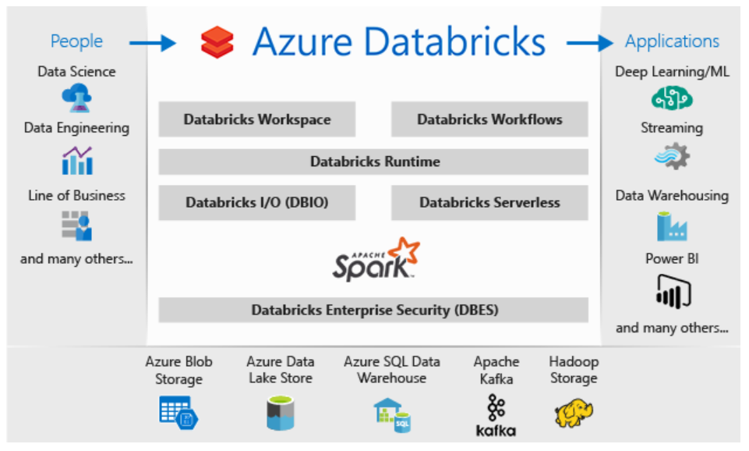

Azure Databricks workflow:
Technology to Process the unstructured big data transform into a structured format which will be meaningful

